**Assignment -2**

Data Analytics

| Assignment Date | 28 September 2022 |
| --- | --- |
| Student Name | Ms. A.Inbasekaran |
| Student Roll Number | 19ITA22 |
| Maximum Marks | 2 Marks |

**Dashboard:**

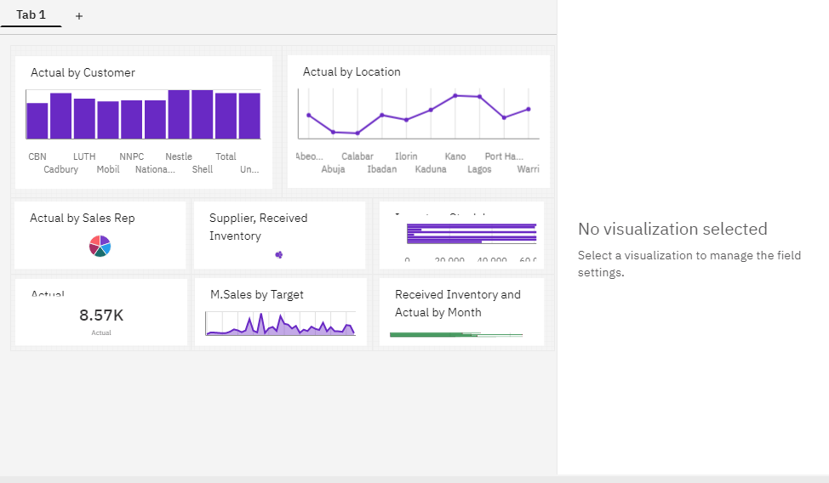

**Link:**

https://us3.ca.analytics.ibm.com/bi/?perspective=dashboard&pathRef=.my_folders%2FAssignment-2%2FPharma%2BMonthly%2BSales%2BAnalysis%2BCustom%2BDashboard&action=view&mode=dashboard&subView=model00000183846efe12_00000000

**Question-1:**

Sales By Customer.

| **Solution:** |
| --- |

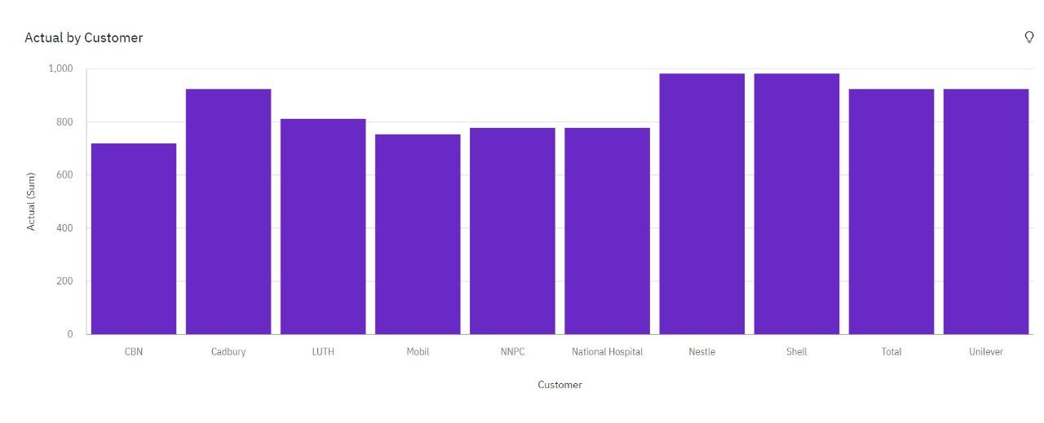

**Question-2:**

Sales By Location.

| **Solution:** |
| --- |

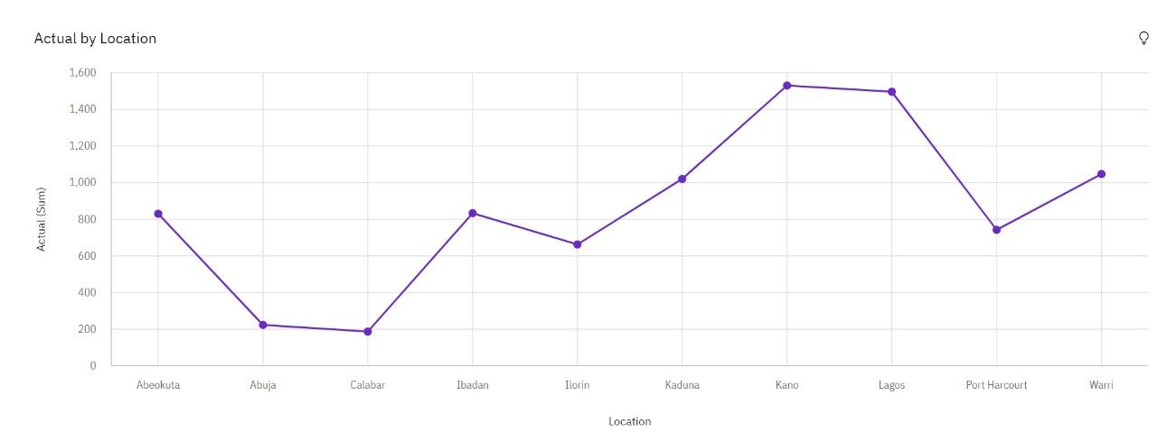

**Question-3:**

Sales By Sales Representative.

| **Solution:** |
| --- |

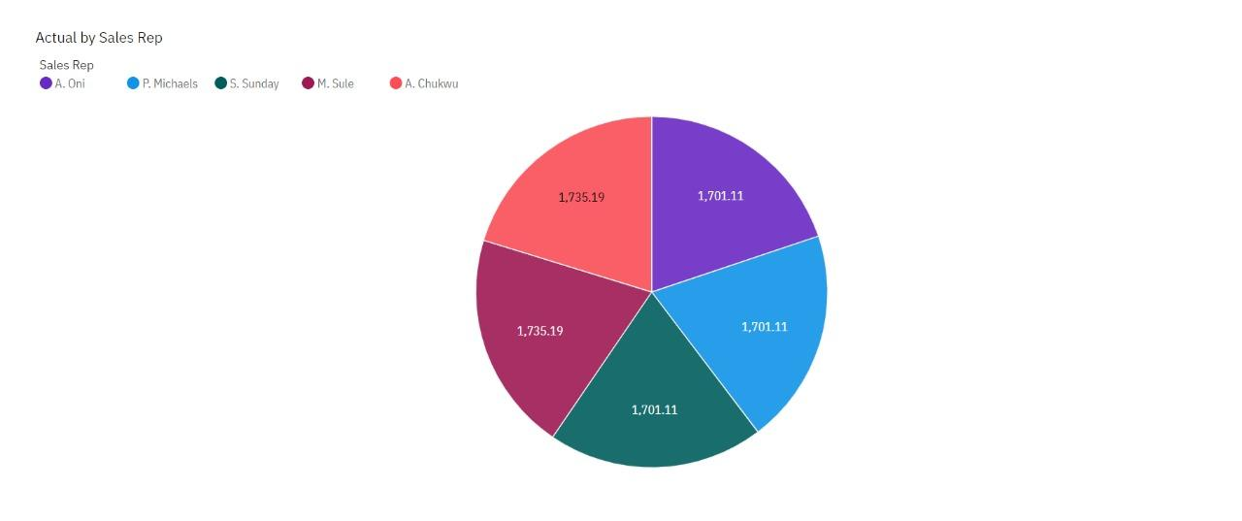

**Question-4:**

Received Inventory From Supplier.

| **Solution:** |
| --- |

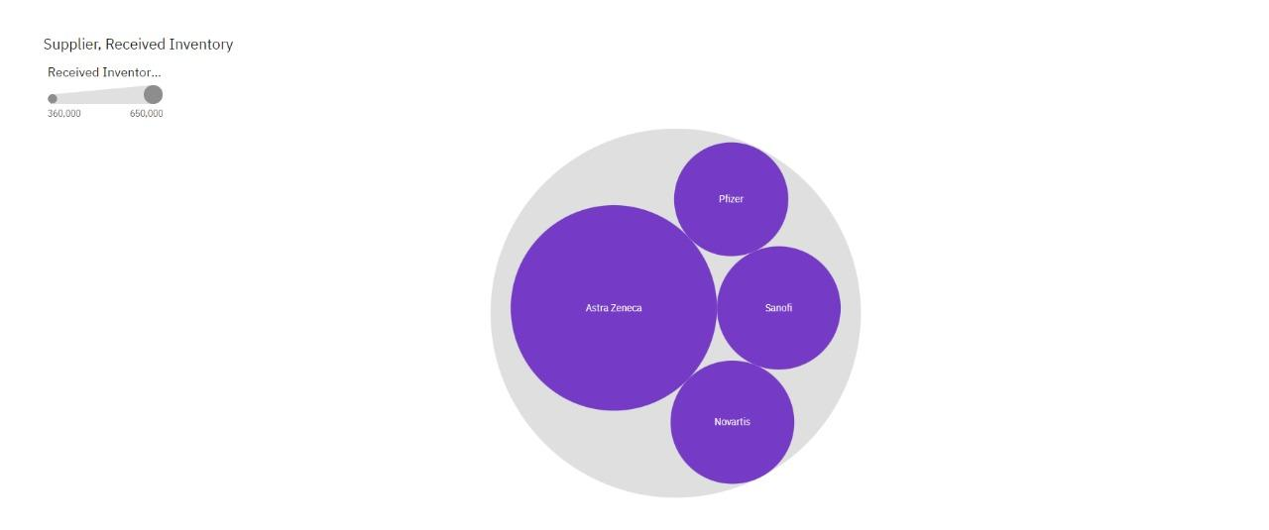

**Question-5:**

Inventory Stock for Warehouse Locations.

| **Solution:** |
| --- |

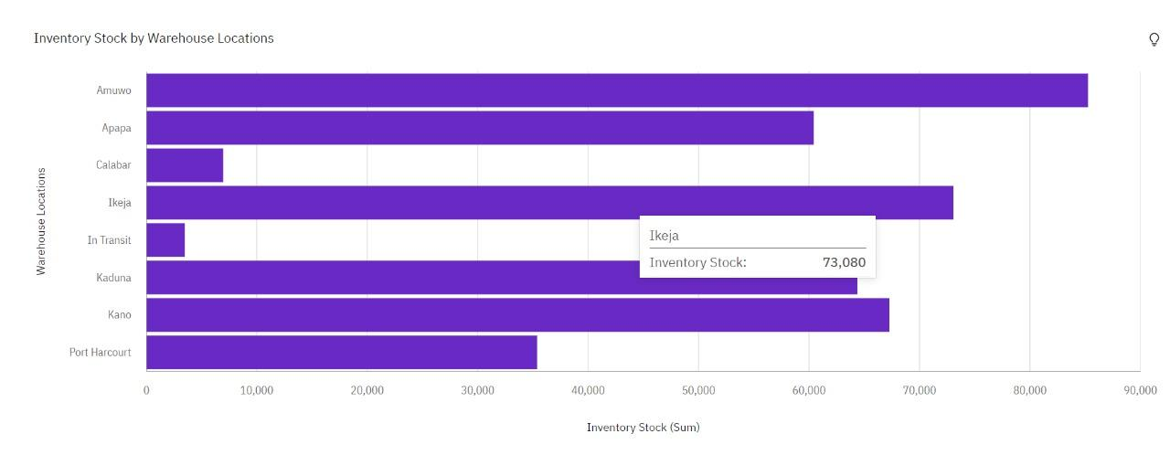

**Question-6:**

Sales Trend.

| **Solution:** |
| --- |
|  |

**Question-7:**

Monthly Sales.

| **Solution:** |
| --- |
| **Question-8:**  Actual and Received Inventory by Month.  **Solution:**     |  | | --- | |